**ASUAR BLAINE M**

**ALJOHN PAUL L.**

**STEP1. IDENTIFY all the necessary OBJECT within the problem domain**

OBJECT: ROOM, PATIENT, TINY HOSPITAL.

**STEP 2. IDENTIFY all the properties and methods/behaviors in the problem statement**

**PATIENT**

* Name
* ID number
* Date Of Birth
* Add Patient(): void
* Search Patient():void
* Update Patient():void
* View Info()

**Room**

* Room type
* Room fee
* Room Number
* Resident Patient

*assign room*

* Outpatient

**TINY HOSPITAL**

* Room type
* Room fee
* Main ()

**STEP 3. Design the MODEL using a Class Diagram STEP 3. Design the MODEL using a Class Diagram** 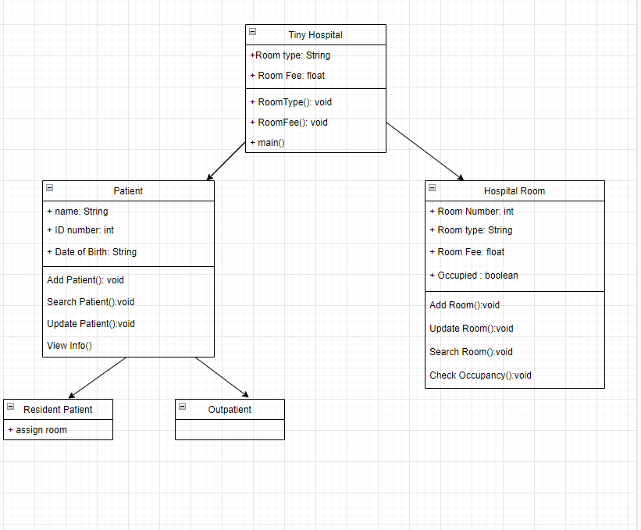

**STEP 4. Implement the class using Java code construct of each interacting**

**entities that you have identified.**



